./

GENESIS - Mini-project Summary Report



|  |  |  |  |  |  |
| --- | --- | --- | --- | --- | --- |
| **Ver. Rel. No.** | **Release Date** | **Prepared. By** | **Reviewed By** | **To be Approved** | **Remarks/Revision Details** |
| 1.0 | 04-12-2020 | Krishnapriya J |  |  |  |
|  |  |  |  |  |  |
|  |  |  |  |  |  |
|  |  |  |  |  |  |
|  |  |  |  |  |  |

**Details**

Contents

Contents 3

Miniproject -1: Calculator 4

Ageing 4

Costing 4

4W1H 4

My product 5

SWOT Analysis: 5

Design 6

Test Plan 7

Git Link 8

Git Dashboard 8

References 8

Fig1. High level design 6

Fig2. Low level design 6

Fig3. High level design 7

Fig4. Low level design 7

Table 1: Costing 4

Table 2: High level requirement 5

Table 3: Low level requirements 5

Table 4: SWOT Analysis 5

Table 5: Test plan 7

# Miniproject -1: Calculator

## Ageing

The history of the calculator began with the hand-operated Abacus in Ancient Sumeria and Egypt in around 2000-2500 BC. These are very simple devices compared to modern calculators consisting of sets of ten beads on a series of rods held in place on a quadrilateral frame usually made of wood. In 1617 a Scottish Mathematician, John Napier described the workings of a device that would come to be known as Napier's bones. The bones (rods) were very thin with each being inscribed with multiplication tables. In 1642 one Blaise Pascal created a device that could perform arithmetic operations with just two numbers. His machine comprised of geared wheels that could add and subtract two numbers directly and also multiply and divide them by repetition.

Europe saw the next stage in the development of Mechanical calculators during the 17th Century. As late as the 1980s the use of slide rules was part of many countries school curricula and was considered a fundamental requirement for millions of school children to learn. The first solid-state electronic calculator was created in the early 1960s. Pocket-sized devices became available in the 1970s, especially after the Intel 4004, the first microprocessor, was developed by Intel for the Japanese calculator company Busicom. The first calculator capable of symbolic computing was the HP-28C, released in 1987. It could solve quadratic equations symbolically.2D and 3D math plots began to appear as well as other features like data loggers from input sensors and Wi-Fi and other connectivity capabilities also began to appear.

## Costing

|  |  |  |
| --- | --- | --- |
|  | Table 1: Costing |  |

|  |  |  |
| --- | --- | --- |
| **Year** | **Functionality** | **Cost** |
| 2020 | Basic arithmetic operation | 300 |
| 2022 | Basic mathematical conversion | 400 |
| 2024 | Measurements dealing with area, perimeter and circumference | 500 |
| 2026 | Temperature conversions | 600 |
| 2028 | Banking functionalities | 750 |

## 4W1H

An electronic calculator is typically a portable electronic device used to perform calculations, ranging from basic arithmetic to complex mathematics. The first solid-state electronic calculator was created in the early 1960s. Pocket-sized devices became available in the 1970s, especially after the Intel 4004, the first microprocessor, was developed by Intel. In addition to general purpose calculators, there are those designed for specific markets. For example, there are scientific calculators which include trigonometric and statistical calculations. Some calculators even have the ability to do computer algebra. Graphing calculators can be used to graph functions defined on the real line, or higher-dimensional Euclidean space.

## My product

High level requirement:

Table 2: High level requirement

|  |  |
| --- | --- |
| **ID** | **Description** |
| HL_01 | The calculator should contain the LCD to display the operations under going |
| HL_02 | The calculator should contain the keys such as 0-9, +, -, *, /, ±, =, C, CE |
| HL_03 | In any situation the calculator has to produce a correct result defined by the well-known arithmetic rules. |
| HL_04 | The calculator size should be 6 inches in height and 3 inches in width |
| HL_05 | The LCD display should be 2.5 inch in width and 1 inch in length |

Low level requirement:

Table 3: Low level requirements

|  |  |
| --- | --- |
| **ID** | **Description** |
| LL01 | Numerical inputs should be of type int |
| LL02 | 4 digits input for basic arithmetic operation |
| LL03 | 4 digits input for banking function |
| LL04 | Should raise flags for exceptions |
| LL05 | Faster Execution |
| LL06 | Insert main reset key |

## SWOT Analysis:

Table 4: SWOT Analysis

|  |  |
| --- | --- |
| STRENGTH | * The ultimate strength of the scientific calculator is its user friendly. * And they have all types of operations such as basic calculator, measurement related to area, perimeter, circumference and conversions between different units of distance. * It also contains operations that include conversions of temperature units. |
| WEAKNESS | * Those who want continuous change in their electronic gadgets usually won’t opt for a scientific calculator. * Even though the use of calculators cannot be overlooked, it should not be used as a replacement for the manual method of mathematical problem-solving. * If a student gets into the habit of using calculators to solve all their mathematical problems, he/she will never develop the math skills needed to solve basic mathematical problems. |
| OPPORTUNITIES | * It is easy to solve the mathematical calculations which are quite difficult. * It takes very less time to compute the very difficult problem. |
| THREATS | * To include all the operations in the desired space of the calculator. |

## 

## Design

Behavioral diagram:

High level design

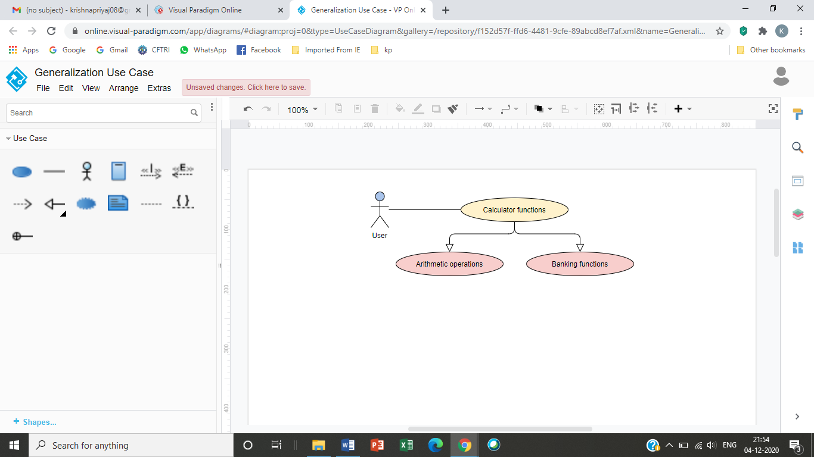

Fig1. High level design

Low level design

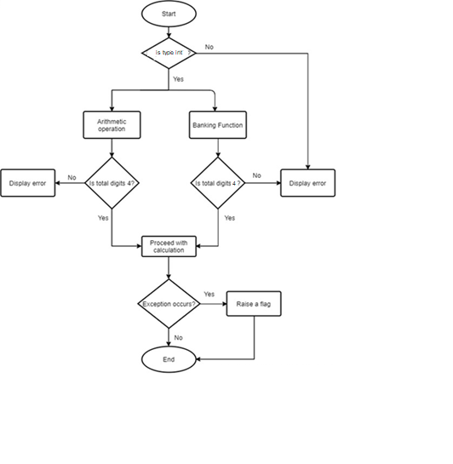

Fig2. Low level design

Structural diagram:

High level design

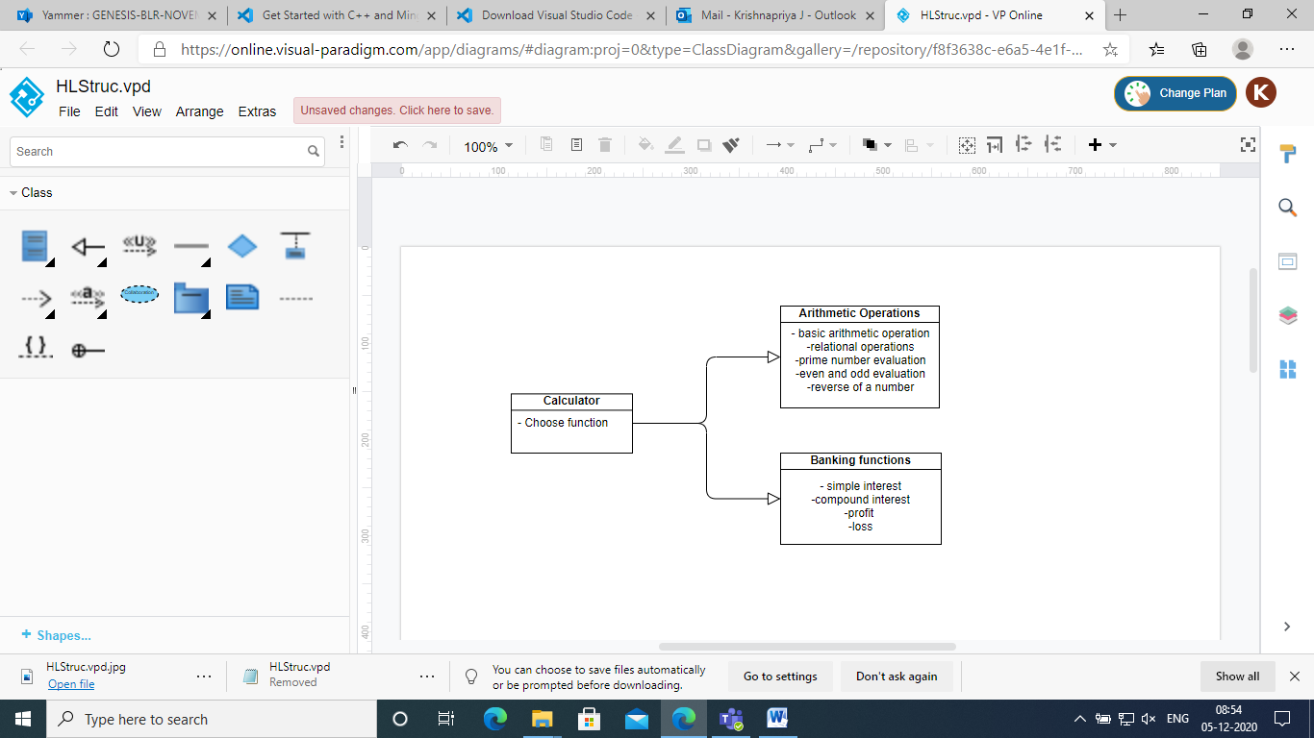

Fig3. High level design

Low level design

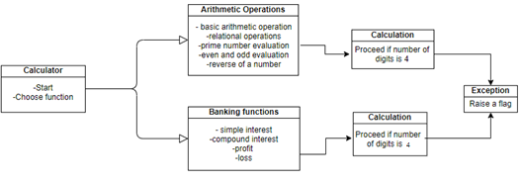

Fig4. Low level design

## Test Plan

Table 5: Test plan

|  |  |  |  |  |
| --- | --- | --- | --- | --- |
| **Test case ID** | **Action** | **Input** | **Expected output** | **Actual output** |
| TC_01 | Addition | 10,2 | 12 | 12 |
| TC_02 | Subtraction | 10,2 | 8 | 8 |
| TC_03 | Multiplication | 10,2 | 20 | 20 |
| TC_04 | Division | 10,2 | 5 | 5 |
| TC_05 | Modulus | 10,2 | 0 | 0 |
| TC_06 | Square | 2 | 4 | 4 |
| TC_07 | Cube | 2 | 8 | 8 |
| TC_08 | Square root | 4 | 2 | 2 |
| TC_09 | Greater than | 10,2 | TRUE(1) | TRUE(1) |
| TC_10 | Lesser than | 2,10 | TRUE(1) | TRUE(1) |
| TC_11 | Equal to | 2,2 | TRUE(1) | TRUE(1) |
| TC_12 | Prime number | 2 | TRUE(1) | TRUE(1) |
| TC_13 | Odd | 3 | TRUE(1) | TRUE (1) |
| TC_14 | Even | 2 | TRUE(1) | TRUE (1) |
| TC_15 | Reverse | 12 | 21 | 21 |
| TC_16 | Simple interest | 5000,6%,5 | 6500 | 6500 |
| TC_17 | Compound interest | 5000,6%,5 | 6,744.25 | 6,744.25 |
| TC_18 | Profit | 6500,5000 | 1500 | 1500 |
| TC_19 | Loss | 5000,4000 | 1000 | 1000 |

## Git Link

<https://github.com/99003155/Calculator.git>

## Git Dashboard

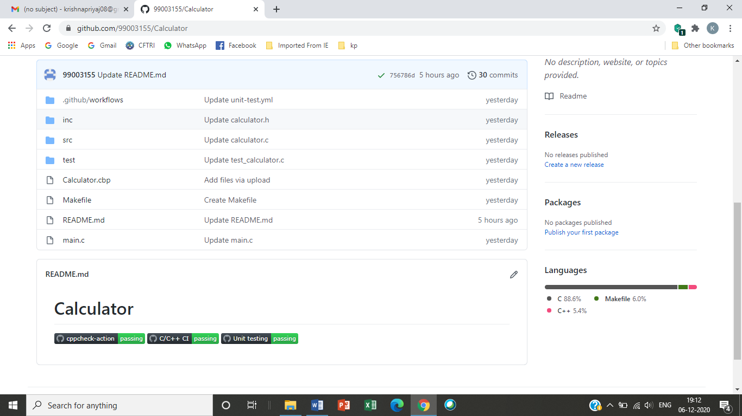

## References

1. [The People's Best Friend: The Calculators' Brief History (interestingengineering.com)](https://interestingengineering.com/brief-history-calculators#:~:text=The%20history%20of%20the%20calculator%2C%20or%20what%20we,on%20a%20quadrilateral%20frame%20usually%20made%20of%20wood.)
2. [Calculator - Wikipedia](https://en.wikipedia.org/wiki/Calculator#Mid-1980s_to_present)